**EXPERIMENT -3: JDK installation and Java program**

**Ques-1:** Do the following

1)Create an Ubuntu container, install Java, and run a hello world program.2)Make an image of this setup.3)Push this image into a private Docker Hub registry.4)Run the image from the private registry by pulling it back.

Step-1: Create an ubuntu container and enter in its shell by using the command:

docker run -it --name=ubucon ubuntu

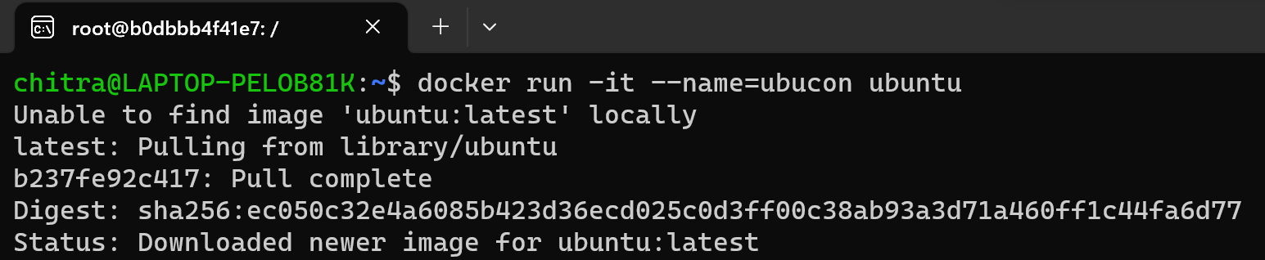

Step-2: Update the ubuntu and then install Java(OpenJDK) inside the container:

apt update

apt install default-jdk -y

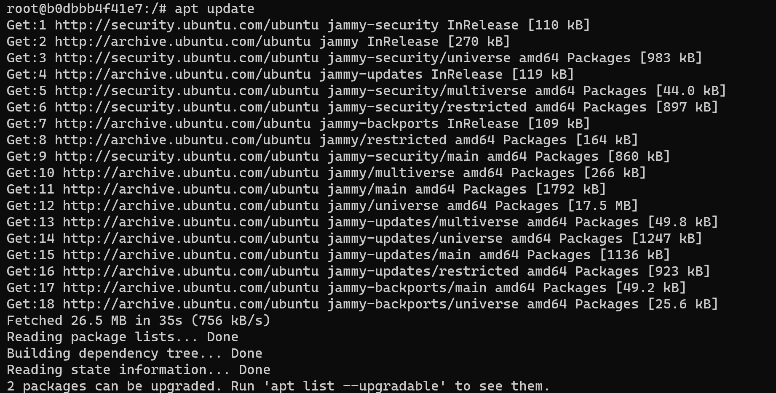

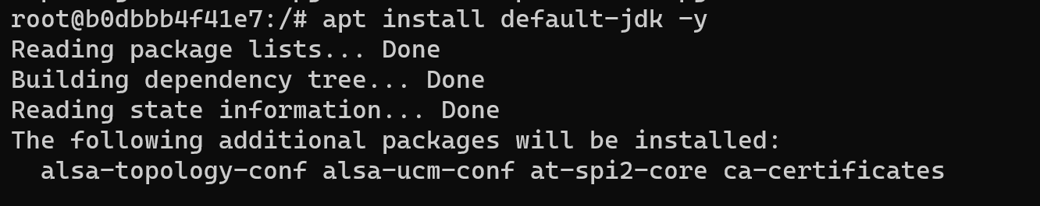

Step-3: Create and run a simple java program using the command:

echo "public class HelloWorld { public static void main(String[] args) { System.out.println(\"Hello, World!\"); } }" > HelloWorld.java



Step-4: Compile the java program and run it using the commands:

javac HelloWorld.java

java HelloWorld

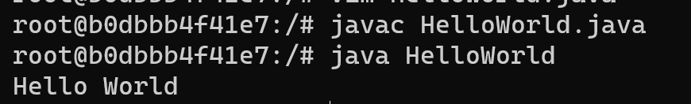

Step-5: Come out of the shell and commit the changes in the container to a new image.

docker commit ubucon newimage



Step-6: Login to your docker account.

docker login

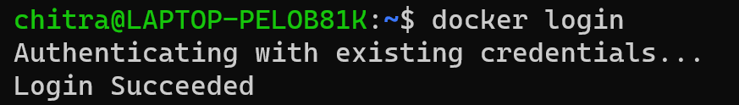

Step-7: Tag the image with the Docker hub username and repository name and then push the tagged image to your private Docker hub repository

docker tag newimage your-dockerhub-username/newimage

docker push your-dockerhub-username/newimage

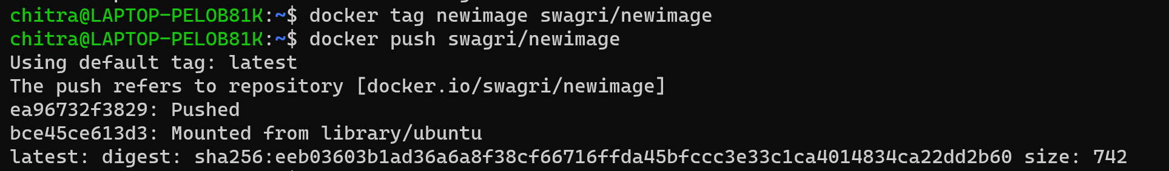

Step-8: Pull the image from your private docker hub repository

docker pull swagri/newimage

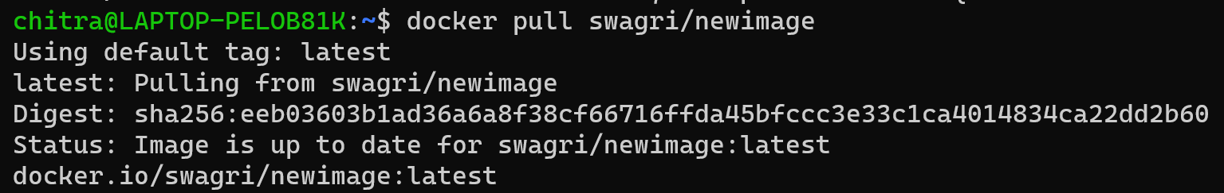

Step-9: Run a container using the pulled image

docker run -it swagri/newimage java HelloWorld

